**How to Design a Brand**

The best rule to follow is to keep the image simple. Simple brand designs are easier to read and are less painful for the livestock.

A brand design consists of two or more symbols. Many brands have three units in the design. Few brands have more than three units.

Brands records include the design of the brand and its position on the livestock.

Left or right:

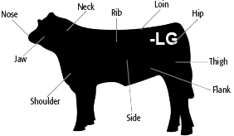

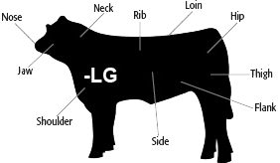

Brands are based on four kinds of marks, used alone or in combination.

* Letter of the alphabet
* Numbers
* Lines and circles
* Pictures

**Letters**

Regular

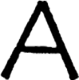

Tilting, tumbling or Toppling

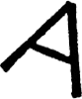

Walking, with legs and feet on the bottom, but seldom on round or square-bottomed letters

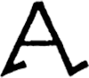

Winged or flying

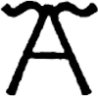

Running, denoted by curves

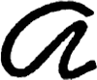

Dragged

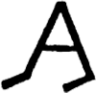

Lazy letters, lying face-up or face-down

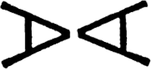

Crazy, upside down

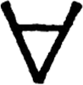

**Numbers**

Walking

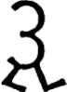

Flying

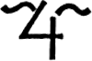

Dragged

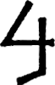

Lazy

Lazy 2 brand

Combinations of letters may be joined

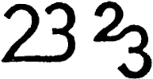

**Lines and Circles**

Bar: a short horizontal line that can be used at the top, bottom or middle of a brand

Bar brand

Rail: about twice as long as a bar, may have letters sitting or resting above it

Rail brand

Two rails

Two Rails brand

Three rails are read as stripes

Stripes brand

Four rails are read as pigpen

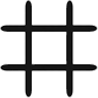

Diagonal lines are read as slashes



Bench

Rafter

Rafter brand

Diamond



Double diamond

Double Diamond brand

Diamond and a half

Diamond and a Half brand

Open A, not half diamond



Box or square



Cross

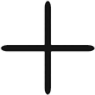

Circle, or with letters, read as the “O”

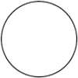

A letter inside a circle is read as Circle Letter, such as Circle K, not O K



Double O

Double O brand

Mashed O or goose egg

Mashed O brand

Buckle

Buckle brand

Lapped circles

Lapped Circles brand

Half circles



Three links

Three Links brand

Quarter circles can point in any direction as long as they stand by themselves

Quarter Circles brand

A quarter or half circle attached to the top of a letter or figure is read as swinging

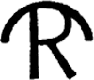

A curved mark attached to the bottom of a letter is read as “rocking letter,” such as a rocking H

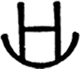

If reversed, lowercase h is attached at a curved mark, it is read as rocking chair

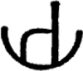

A letter above a quarter circle is read “letter quarter circle,” such as H quarter circle

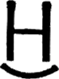

The letters C and U often look like horseshoes



A cross with quarter circles at the ends of all 4 arms is called a “cross wrenches”

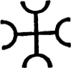

Three Cs joined by a bar is read as a “chain C”

Chain C brand

Two Cs joined by a bar can be read “C bar C” or “lazy wrench”

Lazy Wrench brand

Brands are read from left to right, top to bottom, from outside in.

Sometimes when the letters or symbols are joined, the word “connected” is included in the reading.

Samples:

* W F Connected brand
* Four F Connected brand
* K L Connected brand
* T H Connected brand
* J N B Connected brand
* H K Connected brand
* T T Connected brand
* M L Connected brand
* 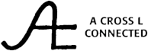

However, often the symbols are read as though they were separated by space.

Samples:

* 
 